SP-G Flow Actuator

Instructions
for ATEX applications
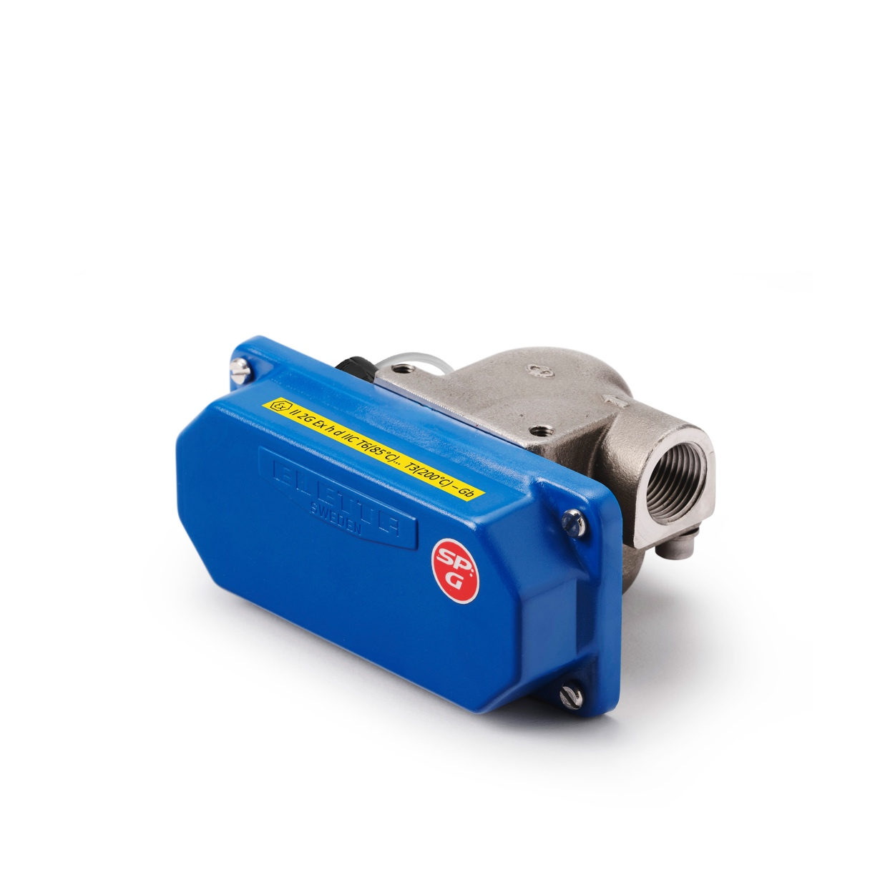

Table of contents
Instructions 1
1. Scope 3
2. Device description 3
2.1 All different models are according to codification table below. 5
2.2 Different SP-G models 6
3 Installation and operating conditions 7
3.1 Equipment approval category 7
3.2 Type of protection 7
3.3 Gas Group 7
3.4 Temperature Class 7
3.5. Ex d b microswitch 7
3.5.1. Maximum switching capacity 8
3.5.2. Electrical connection 8
4. ATEX labeling 8
5. General notes 9
6. Contact 10

1. Scope
These instructions are applicable only to devices that have application options for use in
hazardous areas (intrinsically safe and explosion-proof devices). For all other data, use the
Manual Eletta Flow switch SP-G. If you do not have these documents, please contact the nearest sales office, or download them from the www.eletta.com

Information!
The information in this ATEX instructions only contains the data applicable to explosion protection. The technical data in the installation and operating manual for the non-Ex version shall be valid in its current version, they are not rendered invalid or are replaced by this ATEX supplement.

2. Device description
Exd ATEX SP-G series product description
The SP-G liquid flow actuator is designed to move a lever when an enough flow of liquid is reached. The function is based solely on the flow of the liquid and is not affected by the system’s static pressure; however, the system does require a basic pressure more than 1 bar.

The actuator is customized for applications where alarms for low flows are required while large flows can pass through without any increased fall in pressure.

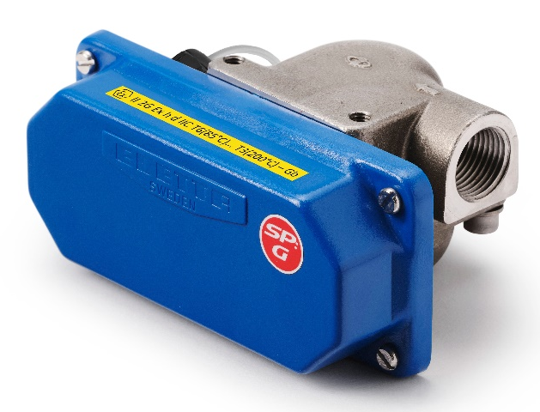

Control unit Pipe section
SP-G consist of two main parts, a pipe section which contain a dimensioned pressure plate and a control unit. Pressure plate allows to choose required actuation flow value from 1.5 to 30 l/min.
The actuator has a variable through-flow area that increases as the flow increases.
The through-flowing fluid lifts a spring-loaded pressure plate. The shaft on which the plate is mounted is mechanically connected to a lever that can actuate a micro-switch. The dimension of the pressure plate controls the position of the lever angle. Lever seals between the pipe section, which is pressurized from the inside of the pipe, and the inner part of the control unit which is exposed to the atmosphere.

Those parts that encounter the liquid are manufactured in Teflon and 316L stainless steel. Synthetic rubber gaskets.

See below a sketch about function and internal parts.
SP-G15

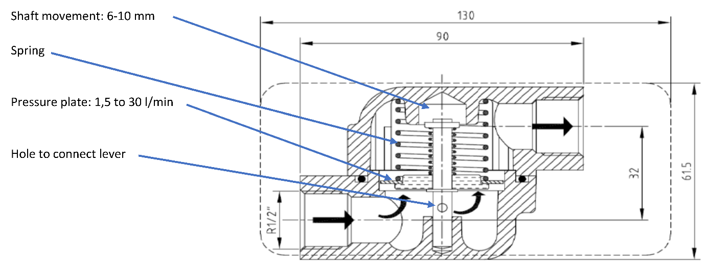
SP-G20

SP-G15 are fitted with ½” female threaded connection and SP-G20 are fitted with ¾” male threaded connection.

In the case of the Exd ATEX version of SP-G series, the mechanical part of the flow actuator is associated to one already Exd ATEX approved microswitch.

Switch marking: II 2G Ex d b IIC T6 Gb

2.1 All different models are according to codification table below.

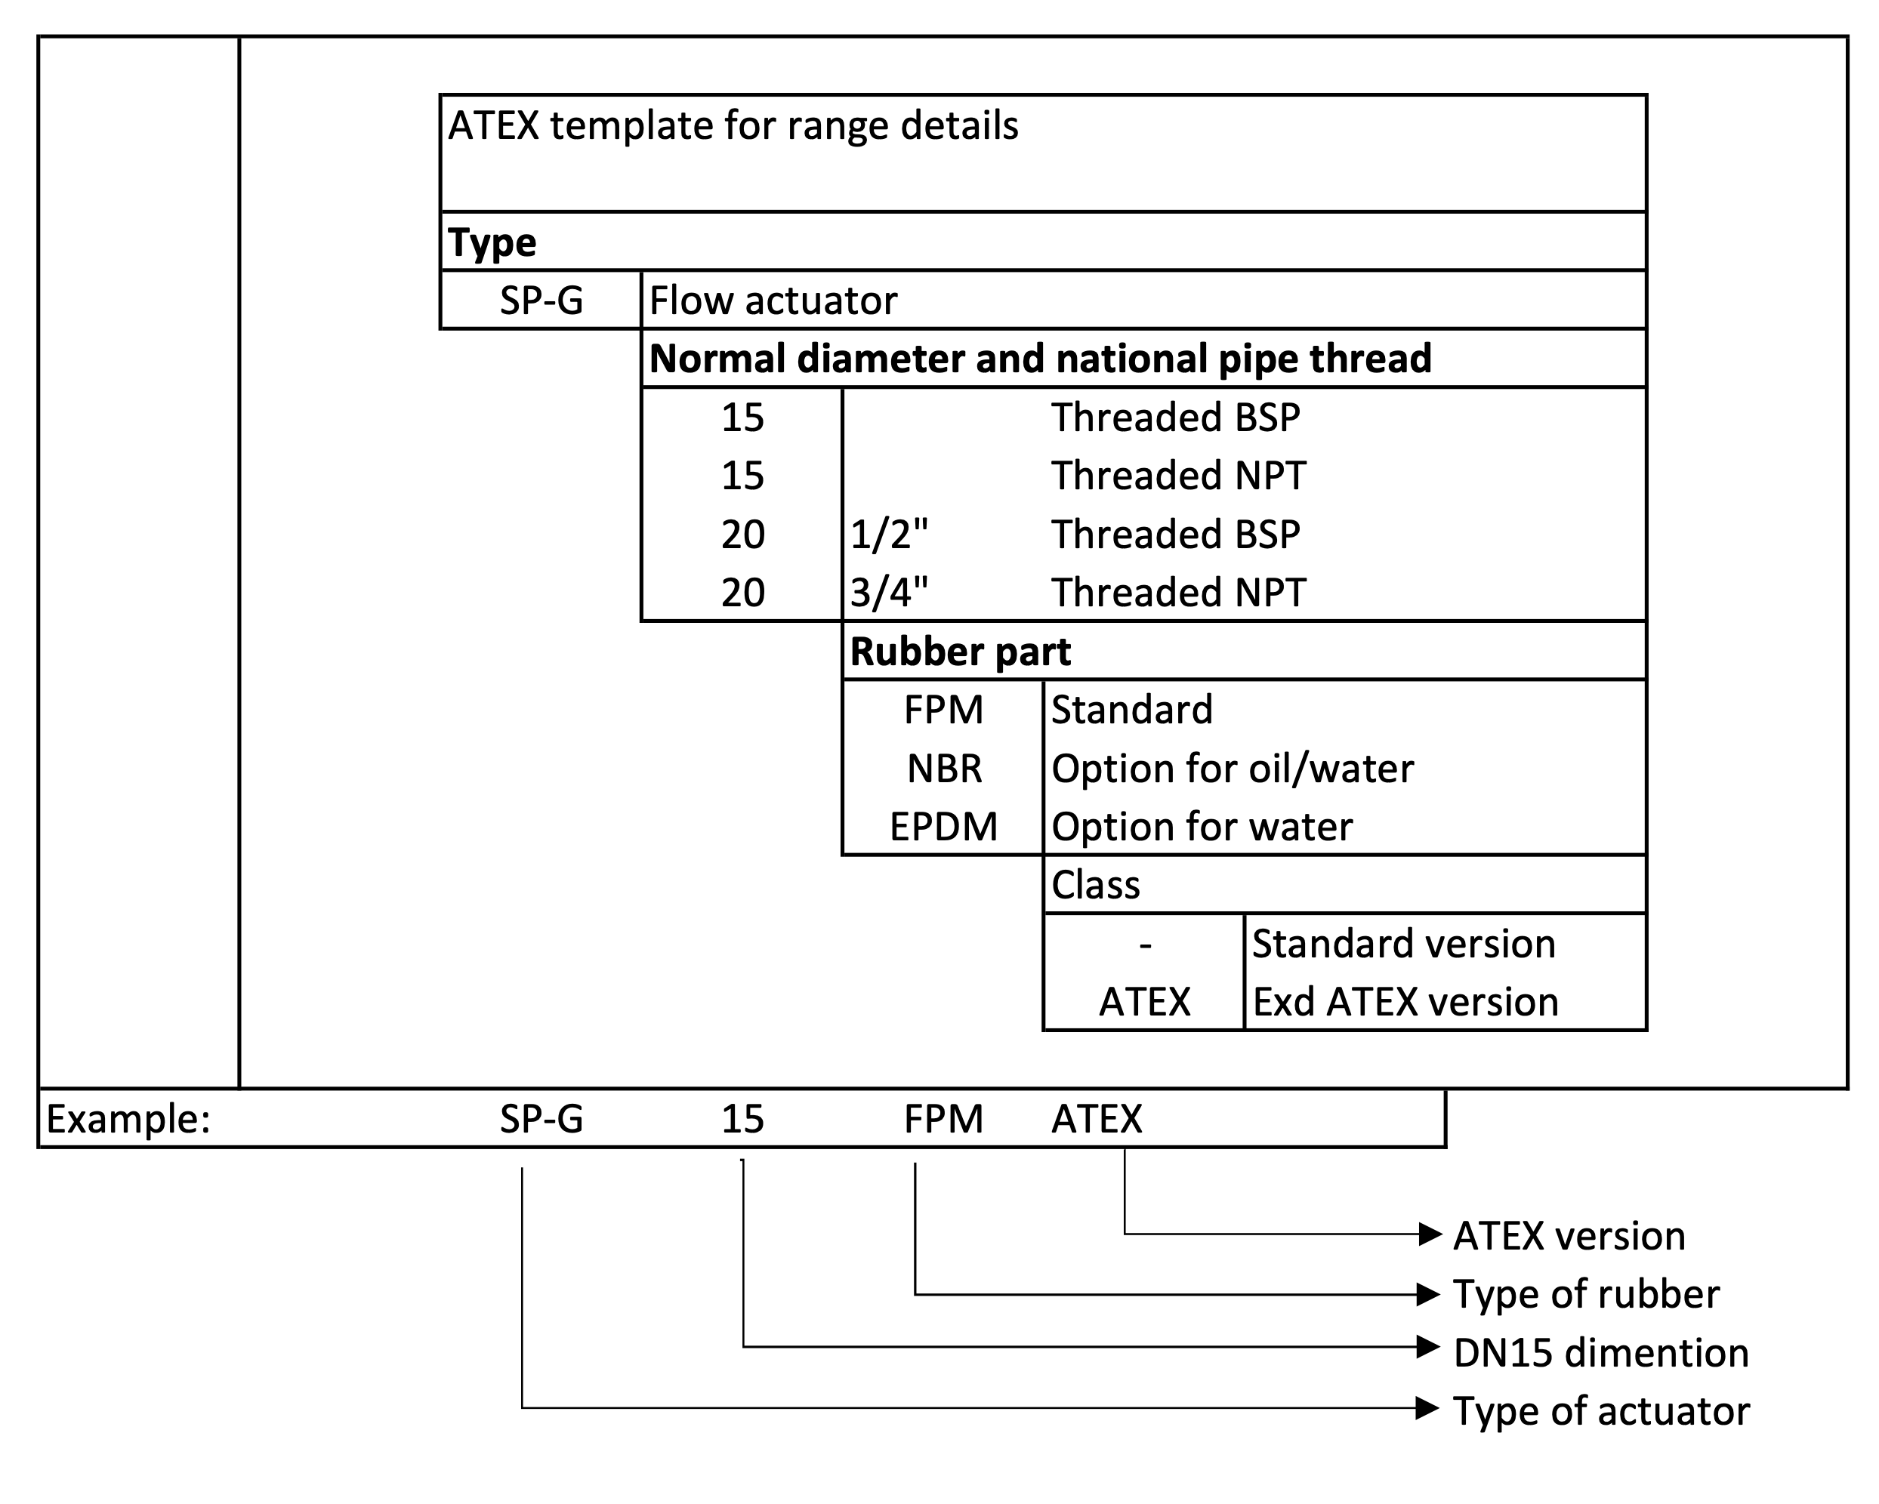
Last part of codification, see standard leaflet.

2.2 Different SP-G models

SP-G15 ATEX SP-G15 NPT ATEX
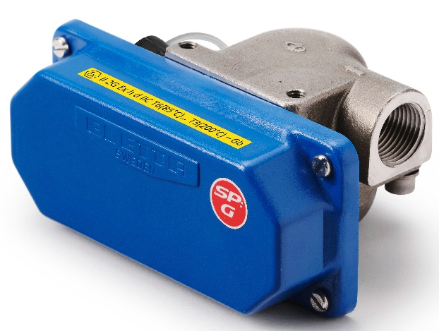
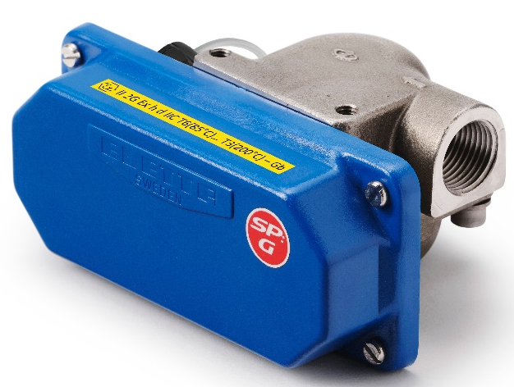

SP-G20 ATEX SP-G20 NPT ATEX
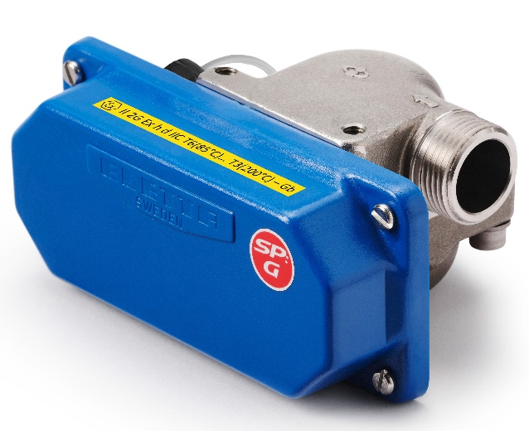

3 Installation and operating conditions

3.1 Equipment approval category
Assembly is designed to be installed inside zone 1, construction category is II 2G (For surface =
II, Instrument category = 2, for gas atmosphere = G)

3.2 Type of protection
The design of assembly is mechanical explosion proofed h d.

3.3 Gas Group
Assembly is designed to be installed into gas atmosphere, for gas group IIC.

3.4 Temperature Class
Maximum temperature which can be reached by flow actuator body is the fluid temperature which is going through. Temperature class will consequently be according to max fluid temperature. Maximum temperature accepted by flow actuator = 120°C
Temperature classes are according below table.
Reminder regarding temperature class values (temperature class value is the maximum surface temperature which can be reached by the flow actuator:
For information Standard is stating: T4: 135°C T5: 100°C T6: 85°C
Ambient  Temperature | Media  Temperature | Temperature  Class
Tamb < 70°C | T media <85°C | T6
Tamb < 70°C | T media < 90°C | T5
Tamb < 70°C | T media < 120°C | T4

3.5. Ex d b microswitch
The assembly including a SPDT ATEX II 2G d b IIC T6, T5 Gb switch. Switches are with 3-meter connection cable. Cable cross section area is 0.75 mm². Cables will have to be connected into
junction box suitable for ATEX area. Recommended models can be advised on request. Do not open junction box while device is energized.

3.5.1. Maximum switching capacity
Switching capacity with AC
 | Ohmic load | Inductive load
250 V | 5 A | 5 A
30 V | 5 A | 5 A
Switching capacity with DC
 | Ohmic load | Inductive load
250 V | 0.25 A | 0.03 A
125 V | 0.5 A | 0.06 A
75 V | 1 A | 1 A
30 V | 5 A | 5 A

3.5.2. Electrical connection

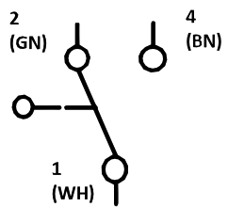
WH: wire color white
BN: wire color brown
GN: wire color green

4. ATEX labeling

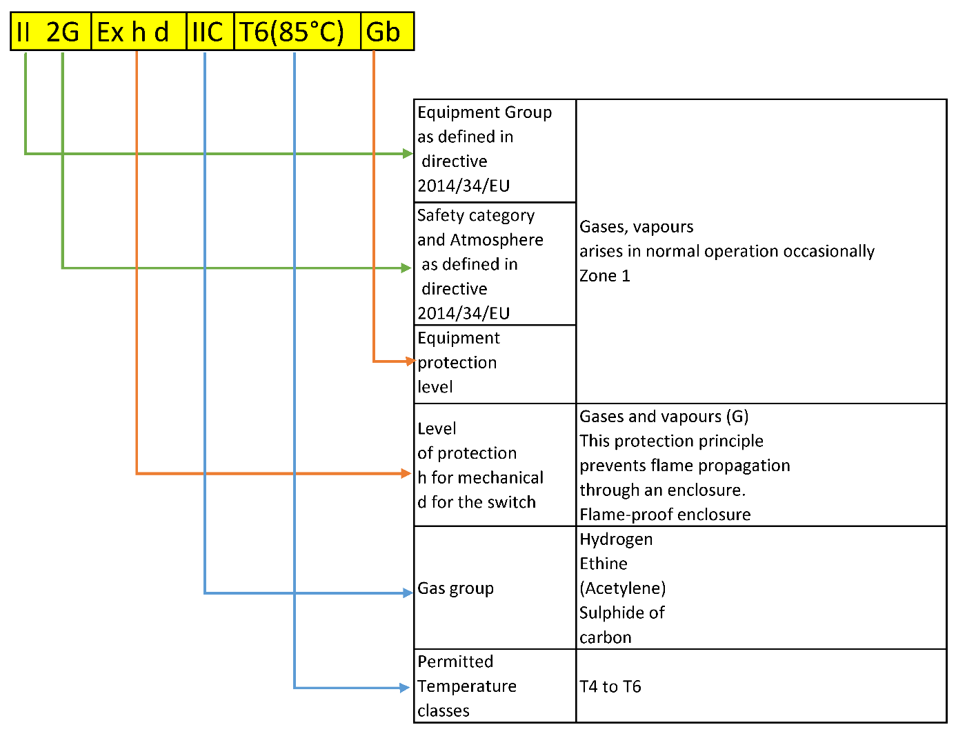

5. General notes

The ATEX version of SP-G series is considered as a mechanical instrument because it is an
assembly between a totally mechanical instrument and ATEX certified microswitch. ATEX
directive 2014/34/EU will then be applicable to this assembly. A risk analysis has been performed for the flow sensor. The assembly is CE marked. Technical file with risk analysis
deposited at LCIE, notified body number 0081, LCIE file N° *******-********.

Nonelectrical component:

Flow actuator according to the codification table.

Electrical component:
Microswitch with connection cable. Marked with II 2G Ex d b IIC T6 Gb.

Ignition risk evaluation of the flow actuator has been carried out according EN ISO 80079-36 for non-electrical equipment for explosive atmosphere. According to assessment table, it appears there is no ignition risk from the flow actuator. Flow actuator is fitted with already ATEX approved microswitch. Association the 2 components is therefore not bringing any ignition risk.

SP-G flow actuator ATEX version are compliant with EPL Gb and can be marked:
II 2G Ex h d IIC T6(85°C) T5(90°C) T4(120°C) – Gb.

Make sure of the correct grounding of the instruments.

6. Contact

Orders/inquiries: +468 603 07 80
Switchboard: +468 603 07 70

E-mail: info@eletta.com
Web: www.eletta.com

Address: Eletta Flow AB
P.O Box 5084
SE-141 05 Kungens Kurva
Sweden

